Welcome to the Lanarkshire Branch: –

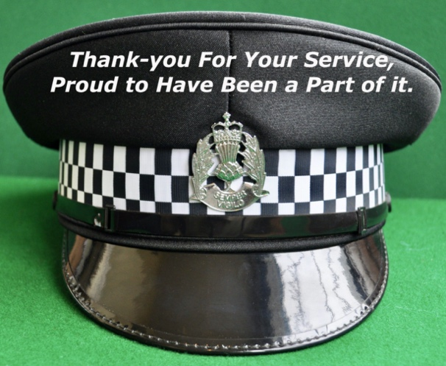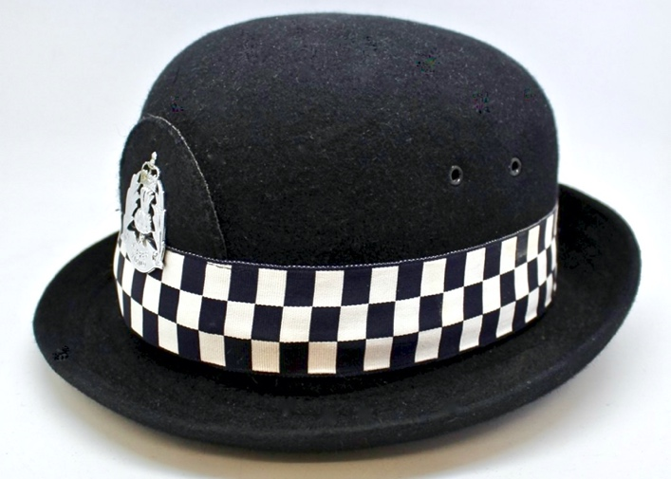

The Lanarkshire section is regularly updated with news and photographs, please visit often.
Also, visit our Facebook Page at www.facebook.com/rpoas.lanarkshire it is very popular with 1,725 follows and 1,698 page ‘likes’. You will find over 2,500 photographs, six video clips and items of interest. New photographs are always welcome and should be forwarded to: - rpoas@henryharper.co.uk. Enjoy a browse but be careful, time flies when you’re enjoying yourself.

The Branch Committee 2019/20

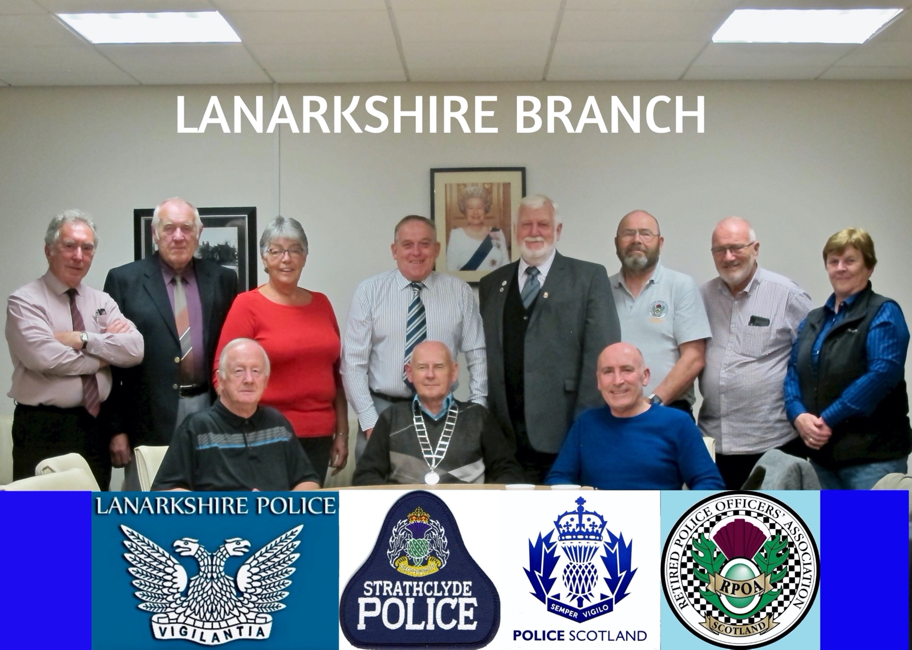

L to R Standing: Evan MacKay; David Gracie; Ellen Callan; Bob Millar; Delmer Bowman; Bill Cushley;
Bill Dempster; Margaret McLean. Seated: Peter Chalmers; Jim Manson and Henry Harper.

Contact List
Role | Fore | Surname | Home Tel | Email
President | James ‘Jim’ | Manson | 01563 850917 | lanarkshirepresidentrpoas@gmail.com
Vice President | William ‘Bill’ | Dempster | 01698 427540 | bill@lanpol.uk
Honorary President | Peter | Chalmers | 01236 428971 | lanpol@yahoo.co.uk
Secretary | Henry | Harper | 01236 755695 | rpoas@henryharper.co.uk
Treasurer | Margaret ‘Meg’ | McLean | 01698 276824 | megzia@aol.com
Extended Family Coord | William ‘Bill’ | Cushley | 01236 762001 | thecush5@hotmail.com
 | Evan | Mackay | 01355 221309 | evanmackay89@gmail.com
 | Ellen | Callan | 01355 249890 | ejayc@blueyonder.co.uk
 | Robert ‘Bob’ | Millar | 01698 792736 | robert.millar1951@gmail.com
 | Delmer | Bowman | 0141 956 3283 | delmerbowmanrpoas@gmail.com
 | David | Gracie | 01698 861674 | graciedavid23@gmail.com

Branch Membership (as at 25/10/2020)

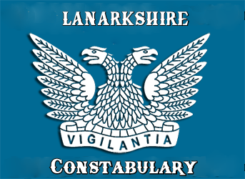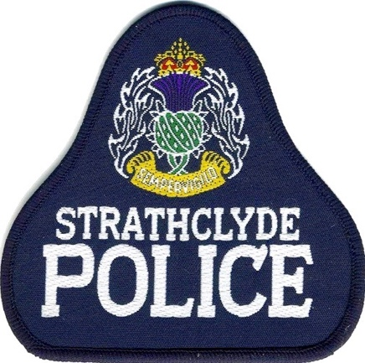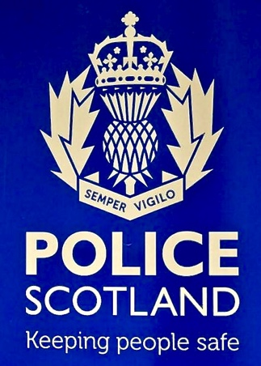

The majority of our members served in Lanarkshire Constabulary; Strathclyde Police and Police Scotland; however, everyone is made welcome.

Membership has steadily increased over the past 5 years to 746; consisting of 693 Ordinary Members; and 53 Life Members. In addition, there are 53 Associate members of RPOAS Lanarkshire.
Our reach spreads far and wide; seven members live abroad: Sparta, New Jersey, USA; Rojales, Alicante, Spain; Albufeira, Portugal; Phoenix, Arizona; Alberta, Canada (2); Larnaca, Cyprus and Western Cape, South Africa.
Down South we have members in Bolton; 2x Kent; Aylesbury; Brough; Norwich; Bedford; Preston and Southampton.
In Scotland as well as the obvious Lanarkshire towns, we have members who live in the Isle of Harris; Nairn; Dingwall; Kinlochbervie; Moray; Banff; Carnoustie; Forfar; Kirkcudbright; Dalkeith; Tranent; Dunbar; West Lothian (4); Edinburgh (2); Falkirk; Kincardine; Tillicoultry; Dunblane; Stirling (2); Kelvindale; Scotstoun; Cambuslang; Mount Vernon; Sandyhills; Stepps (2); Pollokshields; Kingspark; Giffnock; Bowling; Milngavie; Bishopbriggs (4); Kilsyth (2); Kirkintilloch (7); Lenzie (5); Lennoxtown; Cumbernauld (19); Baillieston (8); Bargeddie (4); Gartcosh; Chryston; Uddingston (23); Bothwell (10); Blantyre (16); Cambuslang (10); Rutherglen (17); East Kilbride (69); Eaglesham (2); Clarkston (2); Newton Mearns (4); Helensburgh (2); Troon (2); Dundonald; Ardrossan; Arran; Millport (1); Stewarton; Largs (3); Dalrymple; Ayr (4); Seafield; Prestwick (2); Anstruther (2); St Andrews; Bridge of Weir; Paisley; Dunoon; Ardentinny; Lochgilphead; Dalmally; Renfrew; Erskine; Blairgowrie; Grantown on Spey; Jedburgh. South Lanarkshire (335); North Lanarkshire (276).
Our oldest member is 94 and the youngest is 43 years of age (Ill-health pension).
There is a combined membership of around 6,318 within the 12 branches of the RPOAS.
Please do your retired police friends and former colleagues a favour and encourage them to join our Branch, have them email rpoas@henryharper.co.uk for details.
We would like as many retired officers as possible to be part of the Lanarkshire Branch, the more the merrier as it enhances membership for everyone, so spread the word. We believe the RPOAS is one of the last means of maintaining contact with all our contemporaries and it is in all our best interests to ensure every officer is a part of it.

Extended Family Group: The Branch Extended Family Group (EFG) has 53 members, who are all widows. Details of police widows/widowers should be notified to the Secretary, and anyone falling into this category should be advised that they are entitled to free Associate membership of the Branch and encouraged to join. Members have been able to take advantage of many of the events/functions organised by the Branch and their participation is very welcomed. Please forward details of any bereaved police family members to rpoas@henryharper.co.uk

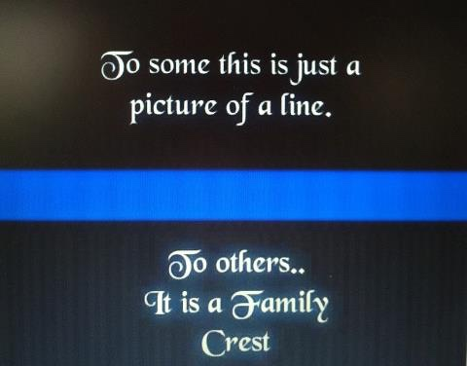

Our Branch is closely affiliated to the Lanarkshire Police Historical Society (LPHS)

The LPHS was established on the 22 May 2013. The Society has a vast array of Lanarkshire Police related memorabilia, uniforms, batons, handcuffs; artefacts; magazines and photographs and are available for displays at open days etc. If anyone wishes to contribute to the collection contact details are provided below.
The Society aims:
 To act as a focal point and network for all who are interested in policing in Lanarkshire.
 To encourage the preservation of relevant police archives and artefacts and promote their accessibility to Retired Police Officers, their families and the general public.
 To forge and maintain strategic links with the local community and relevant academic institutions.
It is also the intention to encourage research into all aspects of the history of the police in Lanarkshire and to publish the useful results of such research.
It is also hoped that items of memorabilia can be collected and ultimately be part of a permanent display somewhere central in the Lanarkshire area.
The society is open to all serving and retired police officers and serving and retired police staff. Membership of anyone out with the above is at the discretion of the committee. The cost is a one-off fee of £15.
If anyone is interested in joining the society they should contact the following for further information.
The Lanarkshire Police Historical Society via their website: – www.lphs.org.uk or email: george.barnsley@lphs.org.uk or henry.harper@lphs.org.uk

Lanarkshire Towns, Villages & Places of Interest
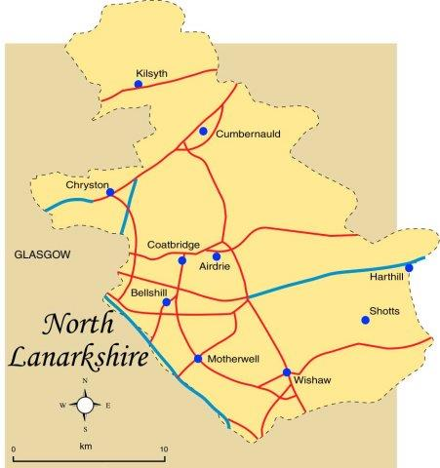

NORTH LANARKSHIRE

Principal Towns: - Airdrie; Bellshill; Coatbridge; Cumbernauld; Kilsyth; Motherwell; Wishaw.

Other Towns and Villages: - Allanton; Auchinloch; Annathill; Banton; Bargeddie; Birkenshaw; Bogside; Bonkle; Cardowan; Calderbank; Caldercruix; Carfin; Carnbroe; Chapelhall; Chryston; Cleland; Forrestfield; Garrion Bridge; Gartcosh; Glenboig; Harthill; Holytown; Longriggend; Millerston; Mollinsburn; Moodiesburn; Morningside; Mossend; Muirhead; Newarthill; Newhouse; Newmains; New Stevenston; Overtown; Plains; Queenzieburn; Ravenscraig; Riggend; Salsburgh; Shotts; Stepps; Tannochside; Viewpark; Condorrat; Croy; Glenmavis; Greengairs and Hareshaw.

Places of Interest: - Airdrie Public Observatory; Bedlay Castle; Carfin Grotto; Clyde Valley; Dalzell House; Dalziel Park; Drumpellier; Greenlink Cycle Path; M&D's; Newhouse Research Site; North Lanarkshire Heritage Centre; Ravenscraig Regional Sports Facility; Summerlee, Museum of Scottish Industrial Life; Strathclyde Country Park; : RSPB, Baron’s Haugh, Motherwell; Blackhill TV transmitters: Palacerigg Country Park, Cumbernauld
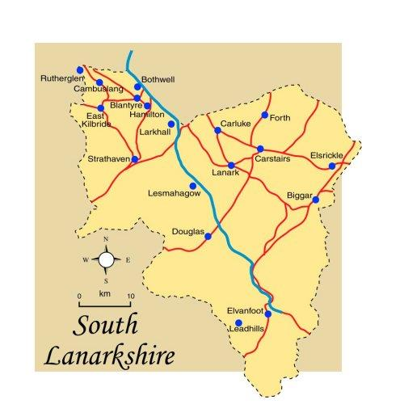
SOUTH LANARKSHIRE

Principal Towns: - Blantyre; Cambuslang; Carluke; East Kilbride; Hamilton; Lanark; Larkhall; Rutherglen; Strathaven

Other Towns and Villages: - Abington; Ashgill; Auchengray; Auchenheath; Auldhouse; Biggar; Blackwood; Bothwell; Braehead; Braidwood; Burnside; Carmichael; Carnwath; Carstairs; Chapelton; Cleghorn; Coalburn; Cobbinshaw; Coulter; Crawford; Crawfordjohn; Crossford; Dalserf; Dolphinton; Douglas; Douglas Water; Elsrickle; Forth; Glassford; Glespin; Kilncadzow; Kirkfieldbank; Kirkmuirhill; Law Village; Leadhills; Lesmahagow; Newbigging; Nerston; Pettinain; Quarter; Quothquan; Rigside; Rosebank; Sandford; Stonehouse; Symington; Tarbrax; Thankerton; Thorntonhall; Uddingston; Waterfoot (Part Of); Wiston; Woolfords; Broughton, Caldermill, Ferniegair, Hazelbank, Jackton, Lamington, Nemphlar, Netherburn, New Lanark, Ravenstruther, Roberton.

Places of Interest: - Hamilton Mausoleum; Bothwell Castle; Strathaven Castle; John Hastie Museum, Strathaven; Low Parks Museum, Hamilton; Chatelherault Country Park, near Hamilton, including Cadzow Castle; Craignethan Castle; David Livingstone Centre, in Blantyre; Dollan Baths, East Kilbride; Falls of Clyde; Little Sparta, near Dunsyre near Lanark; New Lanark, a World Heritage Site; Clyde Valley; Sites of the Battle of Drumclog and the Battle of Bothwell Bridge

Visit these sites for more information: -
https://www.visitlanarkshire.com/explore/
https://en.wikipedia.org/wiki/List_of_places_in_North_Lanarkshire https://en.wikipedia.org/wiki/List_of_places_in_South_Lanarkshire
https://www.visitscotland.com/ search North & South Lanarkshire
https://www.tripadvisor.co.uk/Attractions-g186576-Activities-South_Lanarkshire_Scotland.html https://www.tripadvisor.co.uk/Attractions-g186561-Activities-North_Lanarkshire_Scotland.html

Thanks for your interest.

Best regards,
Henry

