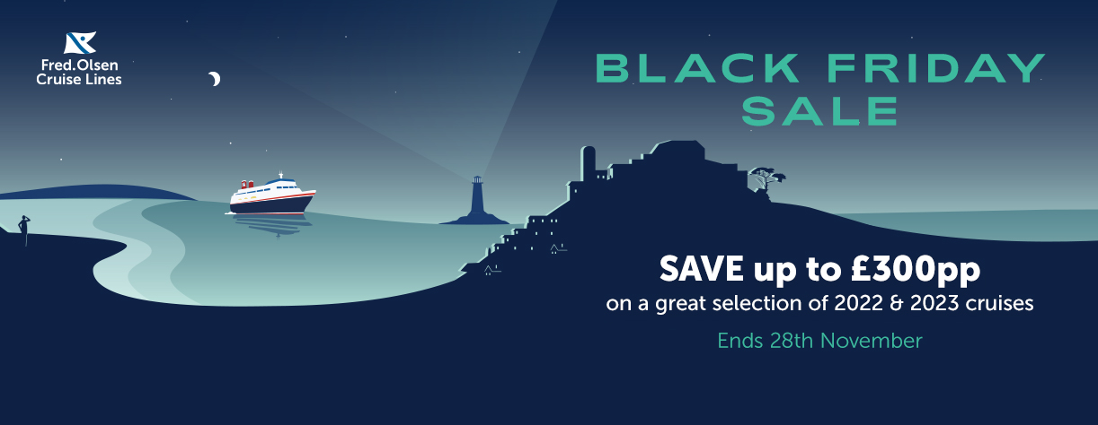

Fred. Olsen Cruise Lines Black Friday Sale

“See the world for less aboard our smaller ships. Choose from 17 hand-selected destinations on itineraries which are crafted to delve into the nature and culture of the places we visit – like seeking out the mesmerising Northern Lights, discovering the diverse landscapes of the Canaries, or cruising the Seine to Medieval French towns. Book now with our Black Friday Offers.”

Promotional assets
A variety of promotional digital assets will be available from Friday 11th November here

When are these offers applicable? | From Monday 21st November to Monday 28th November inclusive.  Promotional embargo – Monday 21st November
What are the details of the offer? | Save up to £300pp on great selection of 2022 and 2023 cruises in our Black Friday Sale.  *Plus additional savings on Suites & Single cabins up to £600 per  person  See the world for less aboard our smaller ships. Choose from 17 hand-selected destinations on itineraries which are crafted to delve into the nature and culture of the places we visit – like seeking out the mesmerising Northern Lights, discovering the diverse landscapes of the Canaries, or cruising the Seine to Medieval French towns. Book now with our Black Friday Offers.
Which cruises are included in this offer and what is the saving? | Cruises with savings of up to £500 per person  Cruises with savings of up to £300 per person  Cruises with savings of up to £200 per person  Cruises with savings of up to £100 per person  Each cruise based on current selling price including saving (Saver fare terms and conditions)
  Cruise ID | Departure date & port | Ship | Itinerary | Nights | Prices from  per person
  L2234 | 22-Dec-2022  Portsmouth | Balmoral | Christmas Celebrations in the Canaries | 14 | £1,599
  Cruise ID | Departure date & port | Ship | Itinerary | Nights | Prices from  per person
  T2232 | 21-Dec-2022  Southampton | Bolette | White Christmas in Norway | 13 | £1,699
  T2301 | 3-Jan-2023  Southampton | Bolette | Winter Warmth in the Canaries | 14 | £1,099
  S2301 | 5-Jan-2023  Liverpool | Borealis | Borealis Searches for the Northern Lights | 15 | £1,299
  L2305 | 24-Mar-2023  Southampton | Balmoral | Escape to the Canaries | 13 | £1,199pp
  T2309 | 11-Apr-2023  Newcastle | Bolette | Exploring the Nordic Capitals | 10 | £899
  T2312 | 3-May-2023  Newcastle | Bolette | Explore the Baltic | 10 | £999
  L2313 | 2-Jun-2023  Rosyth | Balmoral | Medieval Baltic Capitals | 13 | £1,299
  Cruise ID | Departure date & port | Ship | Itinerary | Nights | Prices from  per person
  S2302 | 20-Jan-2023  Liverpool | Borealis | Winter Warmth in the Canaries | 14 | £1,199
  Cruise ID | Departure date & port | Ship | Itinerary | Nights | Prices from  per person
  S2231 | 5-Dec-2022  Liverpool | Borealis | River Cities & German Christmas Markets | 9 | £599
  S2232 | 14-Dec-2022  Liverpool | Borealis | Festive Spanish City Break | 8 | £549
  L2233 | 10-Dec-2022  Portsmouth | Balmoral | Festive Spain & Portugal | 12 | £599
  T2303 | 5-Feb-2023  Southampton | Bolette | Wintertime Norwegian Fjords | 6 | £649
  S2304 | 21-Feb-2023  Liverpool | Borealis | Liverpool to Southampton | 2 | £149
  L2306 | 6-Apr-2023  Southampton | Balmoral | Easter on the River Seine | 5 | £399
  T2311 | 28-Apr-2023  Newcastle | Bolette | Antwerp & Amsterdam in Five Nights | 5 | £399
  S2308R | 20-May-2023  Southampton | Borealis | Two night mini cruise to Liverpool | 2 | £149
Copy for your own social media / web promotions | “Fred. Olsen Cruise Lines Black Friday Sale  See the world for less aboard Fred. Olsen’s smaller ships. Choose from 17 hand-selected destinations on itineraries which are expertly crafted to delve into the nature and culture of the places you visit – from seeking out the mesmerising Northern Lights, discovering the diverse landscapes of the Canaries, or cruising the Seine to Medieval French towns.  Book by 28th November and enjoy savings of up to £300pp”
How much is the All Inclusive Drinks package and tips? | Drinks package at £24.99 per person per night supplement  Pre-payable tips applicable at £5.00 per person per night.
What are the terms and conditions? | These Terms and Conditions are in addition to Fred. Olsen Cruise Lines’ (FOCL) standard Terms and Conditions which are available on our website and on request. Both must be read before booking. All offers may be withdrawn or amended at any time without prior notice, cannot be combined, are subject to availability and cannot be applied retrospectively. Cruise descriptions include optional, chargeable experiences that may be enjoyed independently and/or with optional Fred. Olsen Shore Tours. Shore Tours are subject to availability and service operation. Some ports may be at anchor, intermediate days are at sea.  Savings on selected 2022 & 2023 cruises offer: applicable on selected December 2022 to June 2023 sailings. Applicable for new bookings made from 21/11/22 to 28/11/22, inclusive. Discount is off current selling prices and varies per cruise from £100 per person up to £1000* per person, up to two guests per cabin. *L2234 only. Prices shown are based on Saver Fare and include savings discount. Offer is subject to availability and is capacity controlled. Bookings made via Tour Operators are excluded from all promotional offers.  Saver Fare Terms and Conditions apply.  Full payment is required at the time of booking, 100% cancellation charges apply, no refunds are permitted. Non-transferrable to any other cruise once booked. No room number and / or room grade is provided at the time of booking (room number will be advised on the cruise ticket). Oceans Cruise Club discounts are not combinable with Saver Fares. Oceans points will be earned however. Dining sitting will be allocated at our discretion and will be advised within the cruise ticket. Saver Fare guests can choose to book a specific dining sitting at the time of booking for a supplement of £2.00 per person per night. Table sizes cannot be requested when booking on a Saver Fare.  Savings on selected 2022 & 2023 cruises offer can be combined with the standard onboard discount and/or Oceans’ discount (as applicable). Not combinable with double onboard discount offers. Savings offers not combinable with onboard upgrade offer.  Guests booking under the “Black Friday Campaign” offer cannot combine this with Agent Group deal benefits.

www.fredolsencruises.com/agent


